Solar System  static int year = 0, day = 0;  void init(void)  {  glClearColor(0.0, 0.0, 0.0, 0.0);  glShadeModel(GL_FLAT);  }  void display(void)  {  glClear(GL_COLOR_BUFFER_BIT);  glColor3f(1.0, 1.0, 1.0);  glPushMatrix();  glutWireSphere(1.0, 20, 16); /* draw sun */  glRotatef((GLfloat) year, 0.0, 1.0, 0.0);  glTranslatef(2.0, 0.0, 0.0);  glRotatef((GLfloat) day, 0.0, 1.0, 0.0);  glutWireSphere(0.2, 10, 8);  /* draw smaller planet */  glPopMatrix();  glutSwapBuffers();  }  void reshape(int w, int h)  {  glViewport(0, 0, (GLsizei) w, (GLsizei) h);  glMatrixMode(GL_PROJECTION);  glLoadIdentity();  gluPerspective(60.0, (GLfloat) w/(GLfloat) h, 1.0, 20.0);  glMatrixMode(GL_MODELVIEW);  glLoadIdentity();  gluLookAt(0.0, 0.0, 5.0, 0.0, 0.0, 0.0, 0.0, 1.0, 0.0);  }  void keyboard(unsigned char key, int x, int y)  {  switch (key) {  case ‘d’:  day = (day + 10) % 360;  glutPostRedisplay();  break;  case ‘D’:  day = (day - 10) % 360;  glutPostRedisplay();  break;  case ‘y’:  year = (year + 5) % 360;  glutPostRedisplay();  break;  case ‘Y’:  year = (year - 5) % 360;  glutPostRedisplay();  break;  default:  break;  }  }  int main(int argc, char** argv)  {  glutInit(&argc, argv);  glutInitDisplayMode(GLUT_DOUBLE | GLUT_RGB);  glutInitWindowSize(500, 500);  glutInitWindowPosition(100, 100);  glutCreateWindow(argv[0]);  init();  glutDisplayFunc(display);  glutReshapeFunc(reshape);  glutKeyboardFunc(keyboard);  glutMainLoop();  return 0;  } | 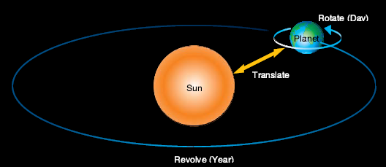  gluLookAt(0.0, 0.0, 5.0, 0.0, 0.0, 0.0, 0.0, 1.0, 0.0)  Defines a viewing matrix and multiplies it to the right of the current matrix. The desired viewpoint is specified by eyex, eyey, and eyez. The centerx, centery, and centerz arguments specify any point along the desired  line of sight, but typically they specify some point in the center of the scene being looked at. The upx, upy, and upz arguments indicate which direction is up (that is, the direction from the bottom to the top of the  viewing volume).  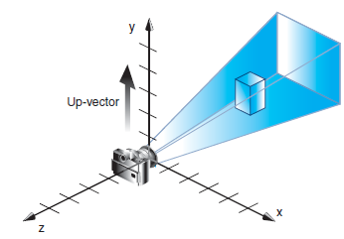

Font Generation  #include <windows.h>  #include <gl/gl.h>  #include <gl/glut.h>  #include <gl/glu.h>  GLubyte rasters[24] = {  0xc0,0x00, 0xc0,0x00, 0xc0,0x00, 0xc0,0x00, 0xc0,0x00,  0xff,0x00, 0xff,0x00, 0xc0,0x00, 0xc0,0x00, 0xc0,0x00,  0xff,0xc0, 0xff,0xc0,  };  void init(){  glPixelStorei(GL_UNPACK_ALIGNMENT,1);  glClearColor(0.0,0.0,0.0,0.0);  }  void display(void){  glClear(GL_COLOR_BUFFER_BIT);  glColor3f(1,1,1);  glFlush();  }  void show(){  glRasterPos2i(20,20);  glBitmap(10,12,0,0,11,0,rasters);  glBitmap(10,12,0,0,11,0,rasters);  glBitmap(10,12,0,0,11,0,rasters);  glFlush();  }  void reshape(int w, int h){  glViewport(0,0,(GLsizei)w, (GLsizei)h);  glMatrixMode(GL_PROJECTION);  glLoadIdentity();  glOrtho(0, w,0 , h, -1.0,1.0);  glMatrixMode(GL_MODELVIEW);  }  void keyboard(unsigned char key, int x, int y){  switch(key){  case 'f':  show();  case 'a':  exit(0);  }  } | void main(int argc, char **argv){  glutInit(&argc,argv);  glutInitDisplayMode(GLUT_SINGLE|GLUT_RGB);  glutInitWindowSize(500,500);  glutInitWindowPosition(100,100);  glutCreateWindow(argv[0]);  init();  glutDisplayFunc(display);  glutReshapeFunc(reshape);  glutKeyboardFunc(keyboard);  glutMainLoop();  }  glPixelStorei(); it describes how the bitmap data is stored in computer memory.  glBitmap () Draws the bitmap specified by bitmap, which is a pointer to the bitmap  image. The origin of the bitmap is placed at the current raster position.  glRasterPos*() The current raster position is the screen position where the next bitmap is to be drawn. Example, the raster position is set by calling glRasterPos*() with coordinates (20, 20), which is where the lower left corner of the F is drawn  